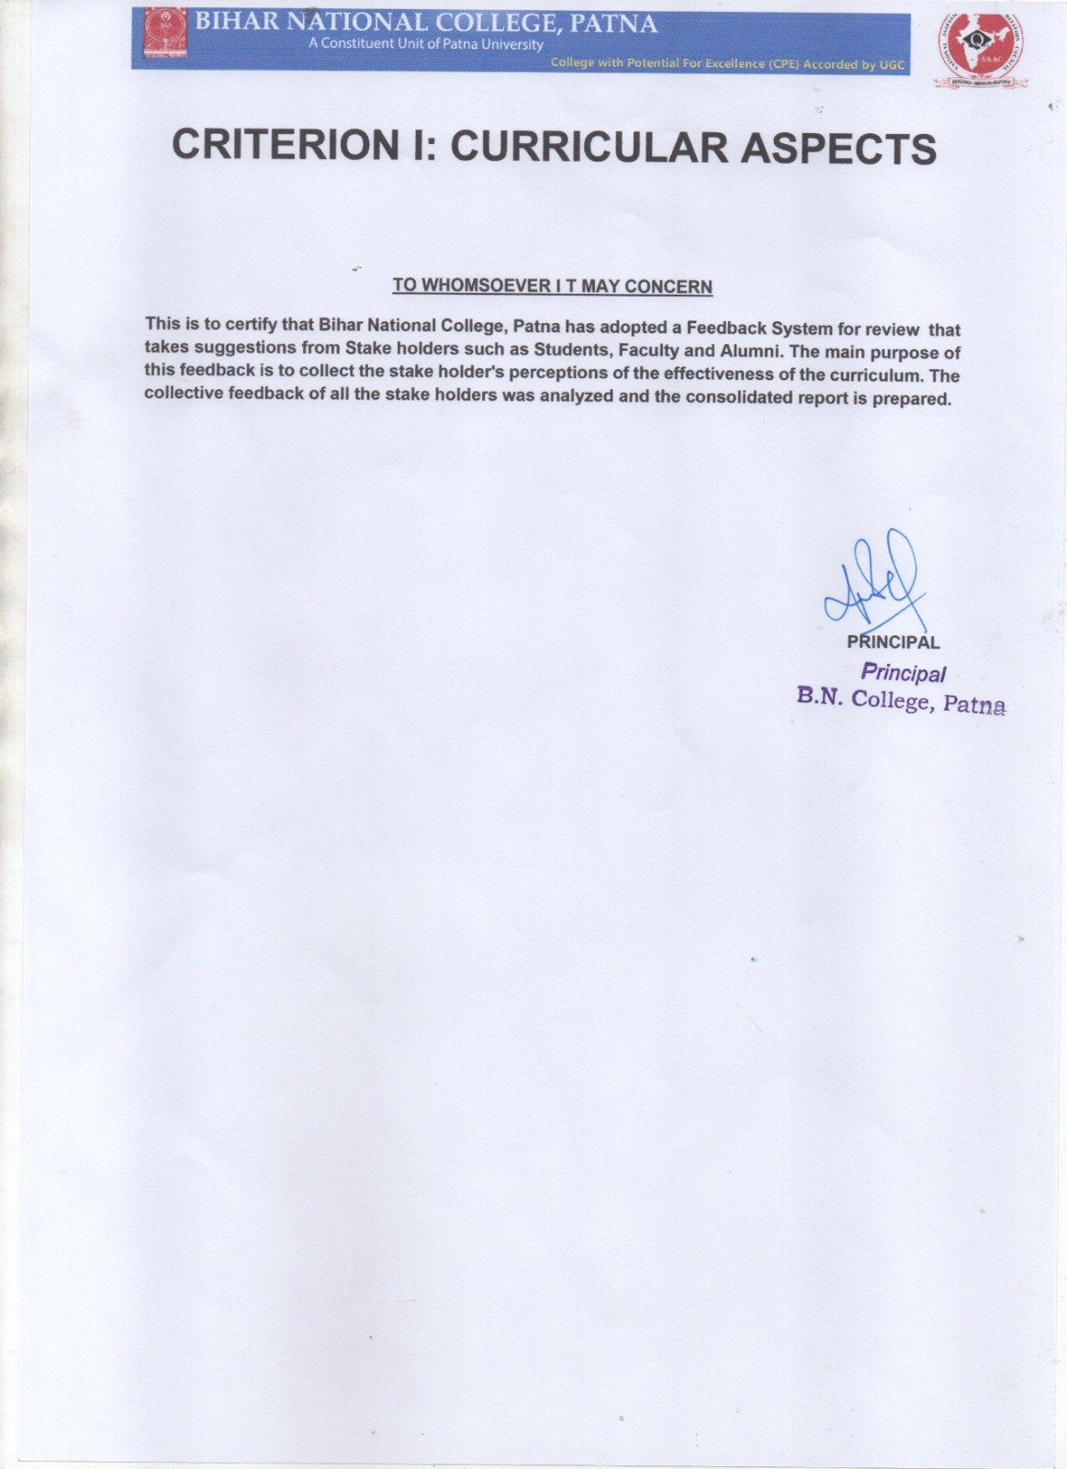

* 1. **- Feedback System**
     1. **- Institution obtains feedback on the syllabus and its transaction at the institution from the following stakeholders:**
        1. **Students**
        2. **Teachers and**
        3. **Alumni**

Feedback Collection (Online):

|  |  |
| --- | --- |
| **Stakeholder** | **URL of feedback form for collection** |
| **Student** | https://[www.bncollegepatna.com/staff_admin/feedback_login.php](http://www.bncollegepatna.com/staff_admin/feedback_login.php) |
| **Teacher** | https://[www.bncollegepatna.com/staff_admin/feedback_alumni3.php](http://www.bncollegepatna.com/staff_admin/feedback_alumni3.php) |
| **Alumni** | https://bncollegepatna.com/staff_admin/feedback_alumni2.php |

Feedback Reports:

|  |  |
| --- | --- |
| **Stakeholder** | **URL of feedback form for reports** |
| **Student** | **https://**[**www.bncollegepatna.com/admin/naac/upload_pdf/HRDq.pdf**](http://www.bncollegepatna.com/admin/naac/upload_pdf/HRDq.pdf) |
| **Teacher** | [**https://www.bncollegepatna.com/admin/pages/samples/alumni-report2.php**](https://www.bncollegepatna.com/admin/pages/samples/alumni-report2.php) |
| **Alumni** | **https://**[**www.bncollegepatna.com/admin/naac/upload_pdf/ilws.PDF**](http://www.bncollegepatna.com/admin/naac/upload_pdf/ilws.PDF) |

**Analysis of Feedback**

|  |  |  |
| --- | --- | --- |
| Stakeholder | Report Analysis | Action Taken |
| Student | Student feedback is collected on courses on 10 point scale (Very good: 9,10; Good: 7,8;  Satisfactory: 6; Below threshold: 0-5) The following questions are asked: | S t u d e n t s f e e d b a c k i s d i s c u s s e d i n IQAC meetings. S t u d e n t represatives are engaged to train rest students to e n c o u r a g e participation in such activities.  Remedial and practical classes for students as p e r I Q A C m e e t i n g resolutions.  F i e l d t r i p s / project work for students as per IQAC meeting resolutions.  Reorganisation o f s p o r t s activities as per IQAC meeting resolutions.  Arrangement of lecture s f rom e x p e r t s f o r g u i d a n c e t o t e a c h e r s a n d students as per IQAC meeting resolutions. |
|  | STUDENTS FEEDBACK ON COURSES |
|  | Learning value |
|  | Applicabibilty/ relevance to real life situations |
|  | Depth of course content |
|  | Extent of coverage of course |
|  | Clarity and relevance of reading material |
|  | Extent of effort required by students |
|  | Relevance and learning value of project/ report |
|  | Semester 1: Paper 1-3 have qualified the student satisfaction with very good and good response but paper 4,5,6 lacks students satisfaction. |
|  | Semester 3: All papers have mixed response in all questions. Their percentages are shown in pie chart. Still larger percentages of students are satisfied with their courses. |
|  | Semester 5: Semester 5 have good response in all papers except in question 7 related to relevance and learning value of project/ report. This shows that their relevance to real life situations should be considered at the highest level of meeting on course curricula. Paper 5 has lacked satisfaction on |

|  |  |  |
| --- | --- | --- |
| Stakeholder | Report Analysis | Action Taken |
| Teacher | Report analysis: Teachers feedback is collected on Syllabus is suitable to the course and need based, Course content is followed by corresponding reference materials, Sufficient number of prescribed books is available in the Library, The course/ syllabus has a good balance between theory and application, The course/syllabus has created interest in the subject area, I have the freedom to propose, modify, suggest and incorporate new topics in the syllabus as and when required, The course/program of studies carries sufficient number of optional papers, Rate your overall experience with the two sets syllabi mentioned on the right, and Infrastructural facilities, such as teachers rooms cabins, class rooms, reading rooms, and toilets are available in the Department, Tests and examinations are conducted well in time with proper coverage of all units in the syllabus, induding assignments and project works, Experience related to the adoption of new techniques of teaching such as ppt presentation, group discussion, learners participation, and other modes of experimental learning, The environment in the department is conducive t o t e a c h i n g a n d r e s e a r c h a n d T h e a d m i n i s t r a t i o n i s t e a c h e r - f r i e n d l y parameters. | Teachers were encouraged to file for projects.  N e w i n f ra s t r u ct u re f a c i l i t i e s a r e being provided to teachers.  Steps have been taken to make administration more friendly. |
|  | Teachers have provided good response in all parameters except in the following parameters: I have the freedom to propose, modify, suggest and incorporate new topics in the syllabus as and when required; Infrastructural facilities, such as teachers rooms cabins, class rooms, reading rooms, and toilets are available in the Department; The environment in the department is conducive to teaching and research and The administration is teacher-friendly. |  |

|  |  |  |
| --- | --- | --- |
| Stakeholder | Report Analysis | Action Taken |
| Alumni | Report analysis: Alumni feedback is collected on parameters: Admission procedure, fee structure, lab. and equipment, classrooms, teacher and student relationship, course suitability to academics and research, and acquiring professional skills. The report shows alumni rated good, very good and excellent to the parameters mentioned in the form. This shows their strong confidence in academic and  administraton. | Steps are taken to organise alumni meet more frequently. |